AGENDA of public meeting of St Augustine’s Community Together Residents’ Association in St Augustine’s Hall, Norwich on 30 September 2010
- Welcome, apologies, circulation of attendance register.
- Minutes of last meeting held on 24 June 20101 (see below)
- Matters arising.
- Presentation of revised redevelopment plans for Anglia Square by Centenary Ashcroft.
- AOB.
- Date of next meeting (9 December 2010).
MINUTES of public meeting of St Augustine’s Community Together Residents’ Association held in St Augustine’s Hall, Norwich on 24 June 2010
- Welcome from the Chair, the Rev Nicholas Vesey. Apologies received from Jeff Compton, Cllr Jago and Cllr Dylan. There were 16 people in attendance.
- The minutes of the last meeting (held on 15 April 2010) were accepted.
- Matters arising:
a) The St Augustine’s gyratory – work was behind schedule and completion was not now expected before November.
b) There was concern about pedestrian safety at the temporary, uncontrolled crossing near Wallace Kings in Botolph Street, in particular inadequate signage.
c) Parking in Sussex Street – David English felt the public consultation into increasing the permit parking spaces in Sussex Street had been poorly managed.
- Councillors’ reports:
a) Cllr Bearman reported that the new pelican crossing traffic lights in the gyratory would be fitted with adjustable timers.
b) Cllr Holmes announced that there would be a Magdalen Street Festival on 2 October.
- Community safety issues:
a) Cycling on the pavements
b) Dog owners not preventing their dogs from entering children’s play areas in Gildencroft Park and the park was generally unclean and littered.
c) Parking on double yellow lines in The Lathes, potentially obstructing access for emergency vehicles – parking wards are seldom patrolling there.
d) Speeding on Sussex Street – 30 mph limit needs to be enforced.
- Other matters:
a) The green space and play area in Leonard Street are underused and need upgrading – ACT would invite City Council’s community engagement officer to next meeting to discuss.
b) There was no new news on the redevelopment of Anglia Square.
- There was a presentation of a bouquet of flowers to ACT’s co-founder and vice-chair
Sally-Ann Reynolds, who was moving on to pastures new.
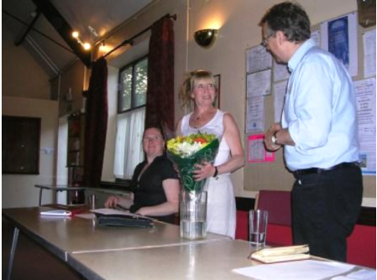
Goodbye Sal, we’ll miss you.

